Seychelles

## Population Data

The data set shows the political stability estimate of the country each year.

## # A tibble: 23 x 5  
## country iso3c date population popCategory5  
## <chr> <chr> <dbl> <dbl> <chr>   
## 1 Seychelles SYC 1996 76417 very small   
## 2 Seychelles SYC 1997 77319 very small   
## 3 Seychelles SYC 1998 78846 very small   
## 4 Seychelles SYC 1999 80410 very small   
## 5 Seychelles SYC 2000 81131 very small   
## 6 Seychelles SYC 2001 81202 very small   
## 7 Seychelles SYC 2002 83723 very small   
## 8 Seychelles SYC 2003 82781 very small   
## 9 Seychelles SYC 2004 82475 very small   
## 10 Seychelles SYC 2005 82858 very small   
## 11 Seychelles SYC 2006 84600 very small   
## 12 Seychelles SYC 2007 85033 very small   
## 13 Seychelles SYC 2008 86956 very small   
## 14 Seychelles SYC 2009 87298 very small   
## 15 Seychelles SYC 2010 89770 very small   
## 16 Seychelles SYC 2011 87441 very small   
## 17 Seychelles SYC 2012 88303 very small   
## 18 Seychelles SYC 2013 89949 very small   
## 19 Seychelles SYC 2014 91359 very small   
## 20 Seychelles SYC 2015 93419 very small   
## 21 Seychelles SYC 2016 94677 very small   
## 22 Seychelles SYC 2017 95843 very small   
## 23 Seychelles SYC 2018 96762 very small

# Population growth data

## # A tibble: 23 x 5  
## country iso3c date popGrowth popGrowthCat5   
## <chr> <chr> <dbl> <dbl> <chr>   
## 1 Seychelles SYC 1996 1.47 slow growth rate   
## 2 Seychelles SYC 1997 1.17 slow growth rate   
## 3 Seychelles SYC 1998 1.96 moderate growth rate  
## 4 Seychelles SYC 1999 1.96 moderate growth rate  
## 5 Seychelles SYC 2000 0.893 slow growth rate   
## 6 Seychelles SYC 2001 0.0875 slow growth rate   
## 7 Seychelles SYC 2002 3.06 high growth rate   
## 8 Seychelles SYC 2003 -1.13 declining   
## 9 Seychelles SYC 2004 -0.370 declining   
## 10 Seychelles SYC 2005 0.463 slow growth rate   
## 11 Seychelles SYC 2006 2.08 moderate growth rate  
## 12 Seychelles SYC 2007 0.511 slow growth rate   
## 13 Seychelles SYC 2008 2.24 moderate growth rate  
## 14 Seychelles SYC 2009 0.393 slow growth rate   
## 15 Seychelles SYC 2010 2.79 high growth rate   
## 16 Seychelles SYC 2011 -2.63 declining   
## 17 Seychelles SYC 2012 0.981 slow growth rate   
## 18 Seychelles SYC 2013 1.85 moderate growth rate  
## 19 Seychelles SYC 2014 1.56 moderate growth rate  
## 20 Seychelles SYC 2015 2.23 moderate growth rate  
## 21 Seychelles SYC 2016 1.34 slow growth rate   
## 22 Seychelles SYC 2017 1.22 slow growth rate   
## 23 Seychelles SYC 2018 0.954 slow growth rate

## Population trend

The plot shows the population trend of the country.

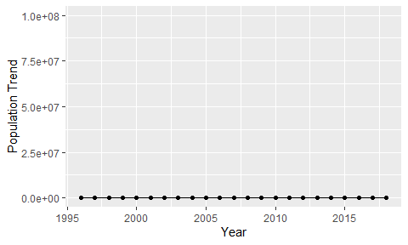

Political Stability Trend

# Population growth trend

The plot shows the population growth rate trend of the country.

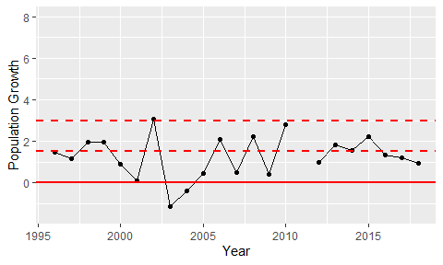

Population Growth Trend